Grain (cereal) foods, mostly wholegrain and/or high cereal fibre varieties
Examples: Bread, cous cous, crumpets, museli, noodles, oats, rice, pasta, polenta, quinoa, wheat flakes, wraps.
Main nutrients: Carbohydrates and fibre.
Carbohydrates are the most important energy source for your body.
Fibre is essential for digestive health and regulating bowel movements. It also makes people feel fuller for longer, assists in regulating cholesterol and blood sugar levels and can be a preventative factor for some diseases.
Includes tinned and frozen varieties.
Main nutrients: Vitamins and minerals; fibre.
All vegetables provide vitamin C. This vitamin keeps tissues in the body healthy, can help heal wounds, can limit infections and assists in the absorption of iron.
Fruit and vegetables have a range of vitamins and minerals. Due to this diversity, it is important to eat a range of fruits and vegetables – eat the rainbow!
These foods can also reduce the risk of some chronic diseases.
Vegetables and legumes/beans & Fruit

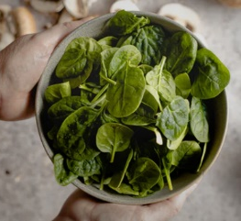

Milk, yogurt, cheese and/or alternatives
Examples:
- Milk – full cream, reduced fat, plain, flavoured, long life, powdered, evaporated, fortified soy.
- Yogurt – full fat, reduced fat, plain, flavoured, fortified soy.
- Cheese
Main nutrient: Calcium
An essential nutrient that helps humans build and maintain strong bones and teeth. It also reduces the risk of tooth decay.

A couple of notes:
- Reduced fat options are recommended for all, except for children under the age of 2.
- When choosing alternative options – for example, soy milk instead of cow’s milk – it is recommended people look for calcium fortified options.

Lean meats and poultry, fish, eggs, tofu, nuts and seeds and legumes/beans
Main nutrient: Protein
Protein is the building block for bones, muscles, cartilage and skin while also helping build and repair tissue. It also assists in carrying oxygen around the body, digesting food and hormone regulation.
Also includes iron and B12 which help oxygen circulate the body and reduces tiredness. Zinc is also found in this food group. Zinc supports a healthy immune system.

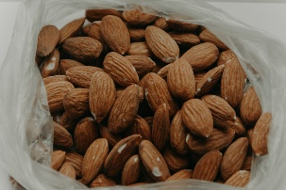
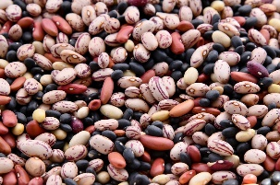
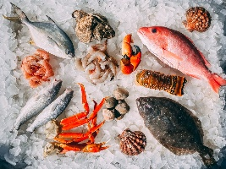

Lean meats Beef
Lamb
Veal
Pork Kangaroo
Lean sausages

Legumes/
beans
All beans
Lentils
Chickpeas
Split peas
Tofu

Nuts & Seeds
Almonds, Pine nuts, Walnuts, Macadamias, Hazelnuts, Cashews, Peanuts, Nut spreads, Pumpkin seeds, Sesame seeds, Sunflower seeds, Brazil nuts

Eggs
Chicken
Duck
Seafood
Fish
Prawns
Crab
Lobster
Mussels
Oysters
Scallops
Clams
Poultry
Chicken
Turkey
Duck
Emu
Goose
Bush birds

High levels of these ingredients are found in these foods. Regular consumption of these foods increases the risk of:
Salt
Sugar
Type 2 diabetes
Obesity
Cardiovascular disease
Poor mental health
Dental caries
Some cancers
Fats & oils
Examples of foods in this category:
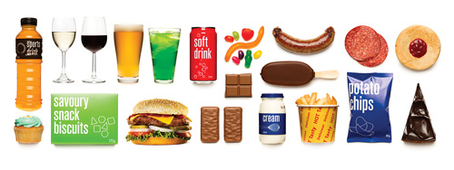
A note on processed meats:
Includes salami, ham, bacon and frankfurts.
These meats have high saturated fats and salt content, making them sometimes choices.
Chips
Lollies
Soft drink
Ice cream
Cheese on toast OR popcorn OR rice cakes/
corn thins
Popcorn hacks:
Spray with olive oil and add different herbs and spices.
Fruit
Water with fresh fruit & mint
Yogurt or fruit smoothie
refers to sugars naturally present in foods.
Natural sugars are found in:
refers to sugars that are:
added during the processing period of foods OR
packaged as sweeteners OR
found in syrup and honey OR
found in concentrated fruit and vegetable juices.
The main source of added sugar consumption comes from:

To avoid the risks of excess sugar consumption, the World Health Organisation (WHO) recommends that daily sugar intake for an adult of a healthy weight is no more than:
Vegetables
Milk
Fruits

Desserts
Baked goods
Sugary drinks

The recommended amount of added sugars for children is:
12 tsp of sugar = 51g
5 tsp of sugar

Topic | Website | URL
Variety of healthy eating topics | Better Health Channel | https://www.betterhealth.vic.gov.au/healthyliving/healthy-eating
Healthy eating advice & recipes | Dietitian’s Australia | https://dietitiansaustralia.org.au
Healthy eating on a budget | No Money, No Time | https://nomoneynotime.com.au
Recipes | Livelighter | https://livelighter.com.au
 | Healthy Food Guide | https://www.healthyfood.com
Fussy eating & childhood nutrition | Child Feeding Guide | https://www.childfeedingguide.co.uk
Healthy eating for sports | Sports Dietitians Australia | https://www.sportsdietitians.com.au

Birth – 6 months

6 months (will vary)

12 months

Breast milk
provides babies with all the nutrition a baby needs within their first 6 months of life and protects babies from infections and allergies.
Formula
is the best alternative for breast milk as it provides the nutrients that babies need to grow.
Foods that can be introduced to baby | Foods to avoid introducing to baby
Iron-rich foods of the right texture:  - Minced meat, poultry, fish  - Cooked tofu and legumes  - Mashed, cooked eggs  Other foods that can be added to the iron-rich foods:  - Vegetables – cooked pumpkin, potato, carrot, broccoli etc.  - Fruit – banana, pear, apple etc.  - Grains – oats, bread, rice, pasta  - Dairy – full fat yogurt or cheese | - Honey  - Raw or runny eggs, including products that contain these type of eggs  - Reduced fat dairy foods  - Wholes nuts and similar hard foods

Babies should be eating roughly 3 small meals a day, as well as breast milk and/or formula.
This is the time when babies are usually first introduced to solid food.
First foods should be smooth or mashed. In the following weeks and months, minced and chopped foods can be introduced.
Babies should still be consuming breast milk and/or formula.
Alexis Letters-Haydock, Dietitian
Australian Breastfeeding Association. (2016). Breastfeeding Timeline. https://www.breastfeeding.asn.au/bf-info/general-breastfeeding-information/breastfeeding-timeline
Behavioural Nutrition. (2020). What are Carbohydrates and Why We Need Them In Our Diet. https://behavioralnutrition.org/healthy-eating-with-carbohydrates/
Better Health Channel. (2020). Milk. https://www.betterhealth.vic.gov.au/health/healthyliving/milk
Eat For Health. (2017). Australian Guide to Healthy Eating. https://www.eatforhealth.gov.au/guidelines/australian-guide-healthy-eating
Eat For Health. (2017). Discretionary Food and Drink Choices. https://www.eatforhealth.gov.au/food-essentials/discretionary-food-and-drink-choices
English, D. (2015). Eat Processed Meat – But Not Every Day. https://pursuit.unimelb.edu.au/articles/eat-processed-meat-but-not-every-day
Health Direct. (2020). Vitamin C. https://www.healthdirect.gov.au/vitamin-c
NHS. (2018). Why 5 a Day? https://www.nhs.uk/live-well/eat-well/why-5-a-day/
Nutrition Australia. (2014). Fibre [Fact Sheet]. https://nutritionaustralia.org/app/uploads/2020/05/Fibre-2014.pdf
Nutrition Australia. (2021). Healthy Eating Pyramid. https://nutritionaustralia.org/fact-sheets/healthy-eating-pyramid/
Piedmont Healthcare. (2021). Why is Protein Important in Your Diet? https://www.piedmont.org/living-better/why-is-protein-important-in-your-diet
Raising Children. (2021). Introducing Solids: Why, When, What and How. https://raisingchildren.net.au/babies/breastfeeding-bottle-feeding-solids/solids-drinks/introducing-solids
The Women’s. (2017). Breastfeeding Your Baby [Fact Sheet]. https://www.thewomens.org.au/health-information/breastfeeding/breastfeeding-overview/why-breastfeed
US Food and Drug Administration. (2020). Added Sugars on the New Nutrition Facts Label. fda.gov/food/new-nutrition-facts-label/added-sugars-new-nutrition-facts-label

